
Technical Resources

Headless eCommerce Setup
for WordPress
Prepared by Clarity Ventures
11/30/2023

Contents
Headless eCommerce 3
Overview 3
Headless eCommerce and WordPress 3
Clarity’s Headless eCommerce 4
Overview 4
WordPress Plugin 4
Headless eCommerce Components and CORS 7
Performance, Security, and General Considerations 8
General Considerations 8
SEO and Marketing 8
Performance 8
Security 8

Headless eCommerce

Overview
Headless eCommerce is a robust, proven model for enabling substantial, turn-key eCommerce capabilities within any UI/UX platform. Typically, this will include but is not limited to implementing the eCommerce within a CMS, such as WordPress. Please see below for a brief video descripting how Headless eCommerce works.

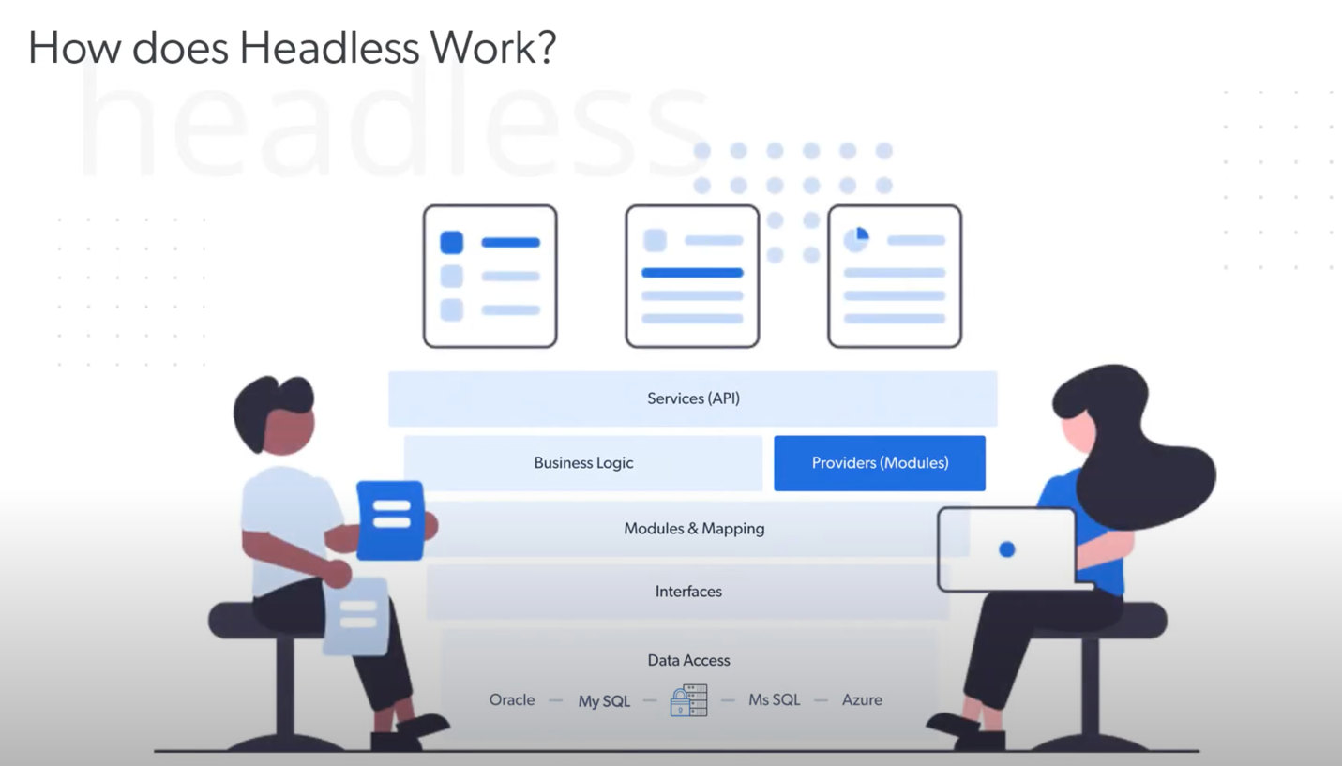

Headless eCommerce and WordPress
WordPress is a very popular CMS with a robust community and overall support for marketing, branding/theming, and plugins. However, it doesn’t have a prominent, highly customizable eCommerce offering that meets the needs of growing businesses, especially as they scale and require business specific workflows and logic.
This is where leveraging a robust eCommerce platform, architected from day 1 for customizability while leveraging robust off-the-shelf capabilities for scaling businesses comes into play. By bringing in an eCommerce platform that meets the business specific needs, while maintaining a well-supported and well-known marketing platform, this can enable the best of all worlds for the business as it scales.

Clarity’s Headless eCommerce

Overview
Clarity’s headless eCommerce brings the Clarity eCommerce functionality to bear for a project. This is achieved primarily with React components that are injected into the header, footer, and content area of the site as needed. These controls will handle anything from showing menu items, cart, user login/users logged in menu options, etc. to a robust catalog page with filtering, the product details page, components that allow for adding an item to the cart within an immersive marketing page, and more. Ultimately the standard components one would expect to be available are and additionally it’s possible to enable project specific components that help deliver on necessary functionality to improve and streamline the process for the project.

WordPress Plugin

Overview
Clarity’s development team has created a plugin that takes care of the heavy lifting to set up the headless eCommerce capabilities within WordPress. This primarily includes the following:
- Injection of header/footer resources (CSS and JS files) specific to the project.
- Injecting (and creating the pages if needed) the most common components and their associated pages. This includes product details, catalog, cart, checkout, user-dashboard, etc. In addition to injecting these pages with the associated components, it also helps to provide examples of how to inject the headless eCommerce components for different use-cases.
- A detailed help/training center built into the plugin. This includes a list of the most used components, and we will have the ability to extend and customize the help center to provide more project specific training/resources for your team upon request.

Installation
The Clarity team will provide a clarity-eCommerce.zip plugin to install. Simply install the plugin and active as shown below.
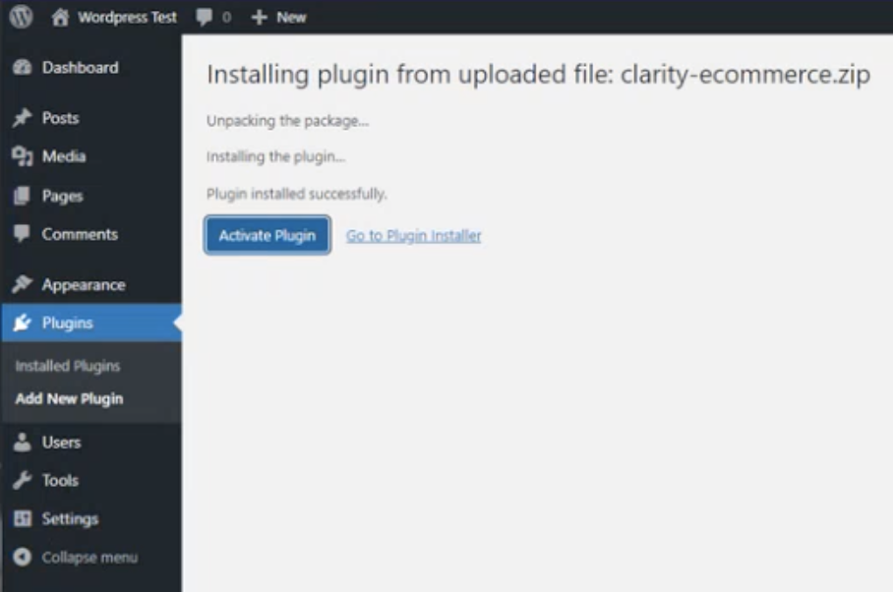

Update Settings
In order to activate the site for headless eCommerce usage, you’ll need to obtain and input the sub-domain information associated with the site.
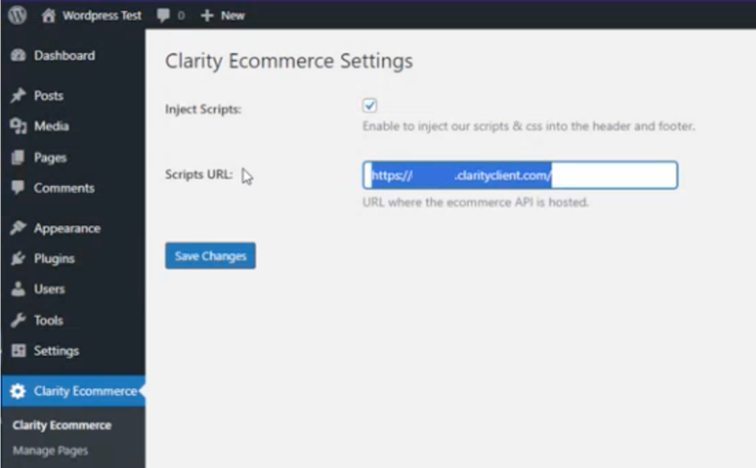

Manage Pages and Inject Components
The Clarity eCommerce WordPress plugin enables page management and component injection at the press of a button for the most common pages and components needed within the site. Feel free to use these options to configure your eCommerce experience rapidly and without any technical knowledge required.
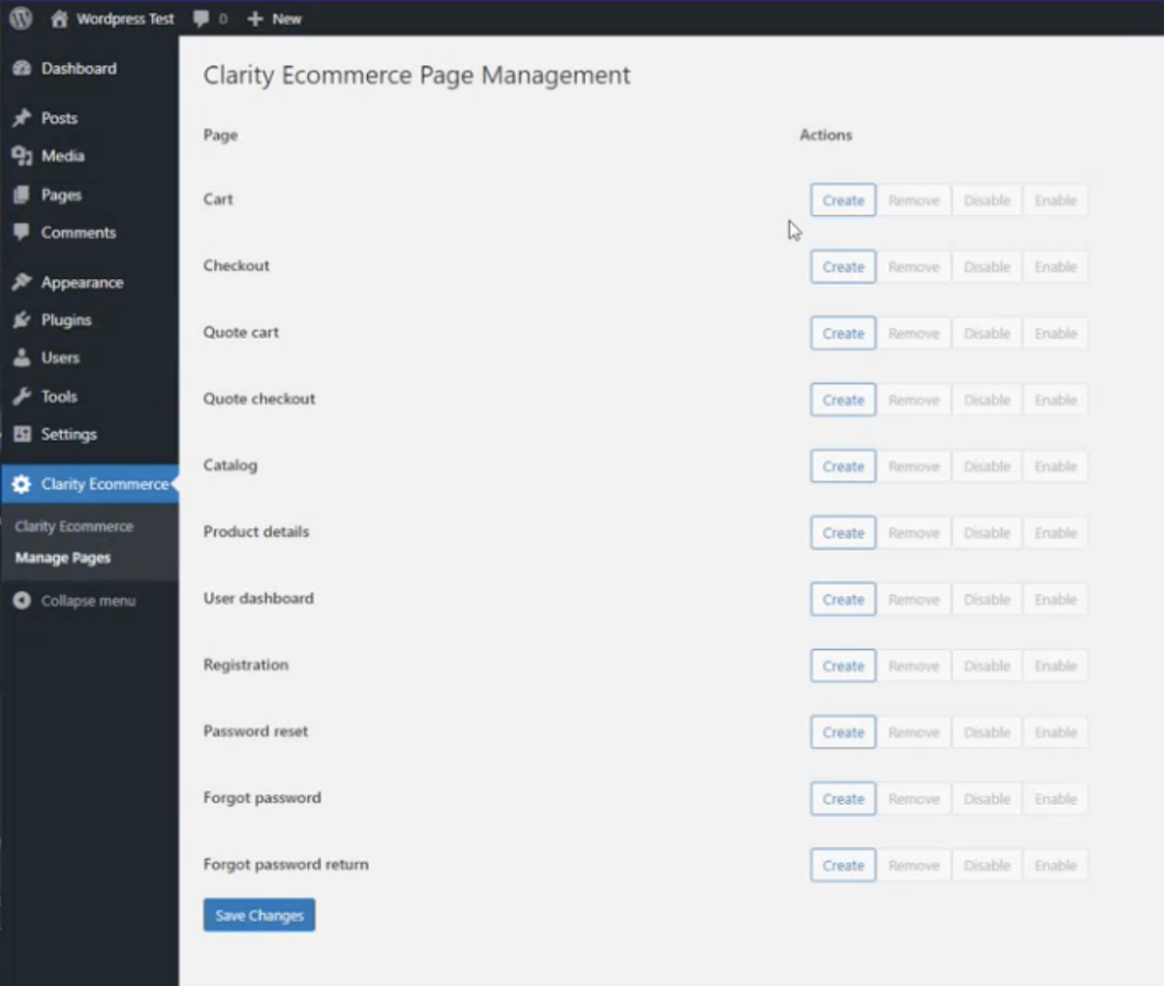

Help Center
The WordPress plugin also contains a help center that lists all the components available as well as resources that are available to assist in and support your usage of the eCommerce platform.

Headless eCommerce Components and CORS
The headless eCommerce components leverage CORS (cross-origin resource sharing) and specifically require white-listing of the requesting domains/sub-domains and associated state persistence components (such as cookies). This helps ensure the security for the data transfer has additional layers of protection against cross-site forgery attempts and other bad-actor attempts that could be made without appropriate security measures in place.

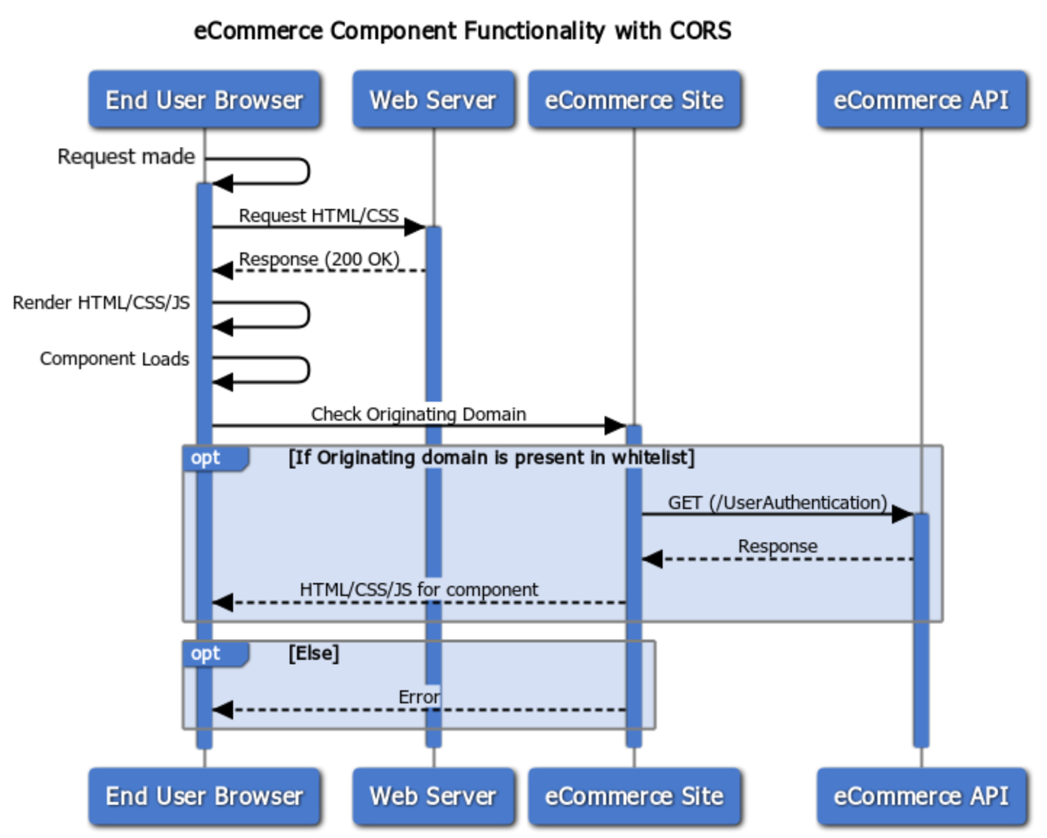

Performance, Security, and General Considerations

General Considerations
In general, the Headless eCommerce embedding is very powerful and easy to use. The technical implementation uses an injection of the CSS and JS files into the pages’ header/footer that use the components. As a result, it’s particularly important to consider that CSS changes (and JS errors or changes) can impact the eCommerce components. This is due to the nature of the components literally being “hydrated” and shown within the DOM (document object model) of the Client Browser. This means the end user gets a fully integrated, native experience with the headless components. However, even simple issues or challenges within the overall site CMS or containing platform can result in breaking or impacting the headless eCommerce experience for users. TLDR: Make sure there is a robust validation step of the impact to the headless eCommerce components when there are CSS or JS changes within the “parent” embedding platform (usually the CMS).
Please also note that the CSS will need to be an area of coordination to ensure there is scoping and a plan to ensure no conflicts/unintended inheritance of the CSS classes. Globally implemented classes can impact the site UI/UX for the headless components so it’s something to be aware of in general and coordinate on.

SEO and Marketing
The Clarity eCommerce platform was designed with SEO and marketing in mind from day one. It’s a foundational pillar of the platform and as such there is substantial depth to the SEO and marketing aspects of the platform. The Clarity team has extensive resources and step-by-step guides that will be catered to your specific project to ensure your team is getting the desired output as well as ongoing recommendations and support.

Performance
The Clarity team has robust, step by step recommendations and resources to ensure very high performance, server-side caching/rendering of the site/components and tree-shaking and optimization/tuning of the assets needed for the headless eCommerce solution. With this in mind, we recommend requesting and coordinating with the Clarity team to ensure this is an active area of coordination for your project.

Security
The Clarity team has robust, step by step recommendations and resources to ensure very high levels of security and optimization/reduction of the security footprint. The Clarity team has extensive resources and step-by-step guides that will be catered to your specific project to ensure your team is getting the desired output as well as ongoing recommendations and support. With this in mind, we recommend requesting and coordinating with the Clarity team to ensure this is an active area of coordination for your project.

