Clarity Process & Policies Cheat Sheet
Sales & Marketing
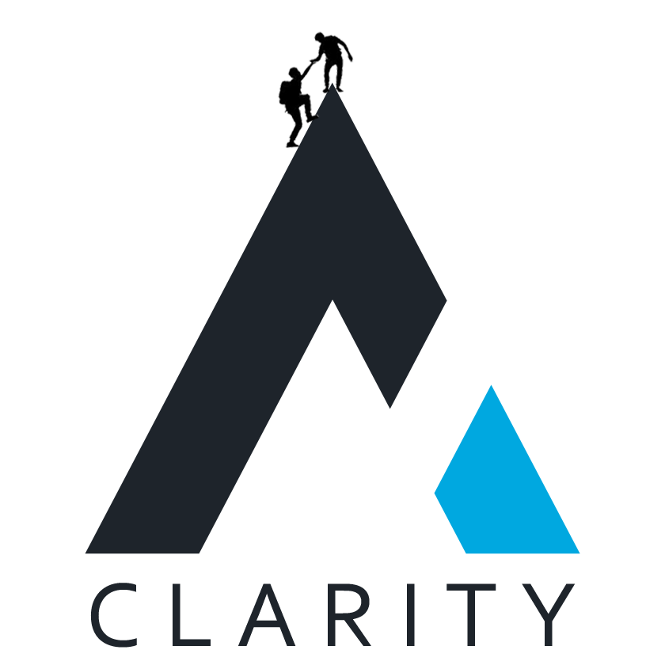
Contents
Overview & Purpose 3
General Clarity Articles 3
PTO Policies 3
Logging Time 3

Overview & Purpose
The purpose of this document is to provide team members with the links to common Nuclino articles that they might require while working at Clarity as well as for their role.

General Clarity Articles

PTO Policies
- PTO Basics: https://app.nuclino.com/ClarityTeam/Clarity/PTOVacation-and-General-Sick-Days-etc-fde4ee8b-f5a2-4e3b-ae9f-d1e7ef48e0f0
- Out of Office Process: https://app.nuclino.com/ClarityTeam/Clarity/Out-of-the-Office-Process-d6c242bb-0abf-4fc0-89ed-b484f388c418
- Rippling How To’s: https://app.nuclino.com/ClarityTeam/Clarity/Rippling---Time-Off-3c52ea0d-6cfd-4b10-86a8-0dbff1d283b0
- Annual Company Holidays: https://app.nuclino.com/ClarityTeam/Clarity/Annual-Company-Holidays-b0547556-2820-42cf-b0a4-132b6299d288

Logging Time
- Easy Projects: http://ep.clarityinternal.com/app/TimeLogs.aspx
  - Credentials will typically be provided by the Operations Team
- Time Logging Policy: https://app.nuclino.com/ClarityTeam/Clarity/Time-Entry-Policy-and-Consequences-e2136d51-994d-4868-a0c4-68499c6a65ac

