Welcome Packet
Helpful tools & resources to get you started at Clarity
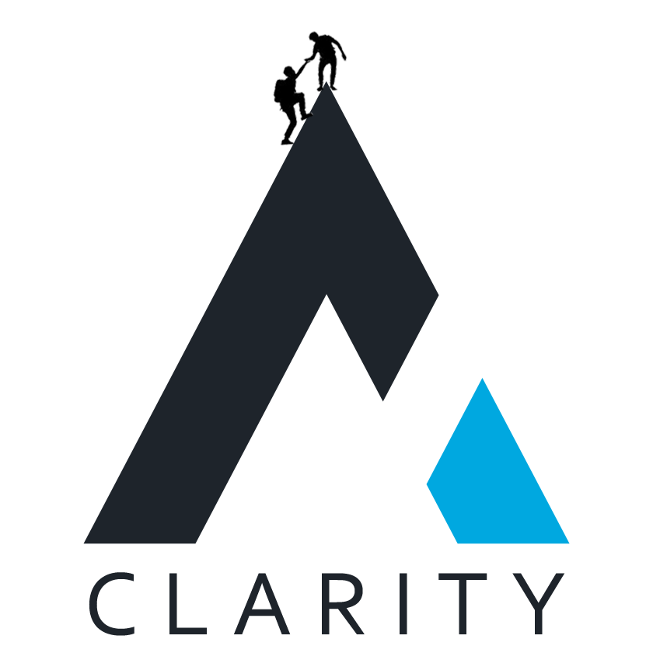
Contents
Our Mission, Vision and Values 3
Mission 3
Vision 3
Values 3
Helpful Materials 3
Key Tools & Training Resources at Clarity 4
Overview 4
Key Training Videos 4
eCommerce Training Videos 4
DotNetNuke Training Videos 4
Additional Training Resources 4
Your account information 5
Overview 5
Exchange E-mail / Office 365 5
Domain Login Info 5
Basecamp Login Info 5
Microsoft Teams Login Information 5
Easy Projects 6
LastpaSS 6
VPN Information 6

Our Mission, Vision and Values

Mission
Deliver world class commerce, portal, and marketplace solutions for growing organizations through a culture focused on industry leading thought leadership, quality, and integrity.

Vision
Dramatically improve the online world with cutting edge solutions tailored to streamline Client business processes

Values
- Deliver world-class solutions that leave a lasting impact
- Build a family spirit with compassion for each other
- Do the right thing - Do whatever it takes - Have fun
- Be passionate about growth and learning
- Focus on positive, action-oriented thoughts
- Operate with integrity, honesty and openness
- Foster a fun and passionate environment for colleagues and Clients
- Develop healthy Client and internal relationships
- Think as a team - Work as a team - Grow as a team
- Be confident yet gracious

Helpful Materials
Clarity Videos:
https://www.youtube.com/user/ClarityVenturesVideo

Key Tools & Training Resources at Clarity

Overview
Clarity leverages the following tools to improve our process workflow.

Key Training Videos

eCommerce Training Videos
These videos are a walkthrough of setting up the eCommerce platform and many of the nuances of the process / steps involved: https://claritymis.wistia.com/projects/uw2ow7lw3o
(Please note you will need to verify / setup a Wistia account from the invite sent to your @ClarityMIS.com email shown in the Email section of this welcome packet.)

DotNetNuke Training Videos

DNNHero.com – please watch the basic administration, skinning and module videos on this site.

Username: receipts@clarity-ventures.com Password: uOLlsmWg

Additional Training Resources

- Important Tools
- Wiki - https://app.nuclino.com/ClarityTeam/Clarity
- Q&A - https://stackoverflow.com/c/clarityteam/questions
- Take a tour of Basecamp: http://basecamphq.com/tour/ (Project management)
- Take a tour of LastPass: https://www.lastpass.com/how-lastpass-works (Password management)
- Take a tour of Microsoft Teams – we use this for office communications https://teams.microsoft.com .
- Take a tour of VSTS–project management – (now called Azure Dev Ops)
  - https://docs.microsoft.com/en-us/azure/devops/boards/sprints/?view=vsts
  - Review from Sprints => How-To Guides

- General Knowledge
- Listen to Career Tools Podcasts - http://www.manager-tools.com/podcasts/career-tools

Your account information

Overview
Below is your key account information at Clarity. You will use LastPass to unlock all other account information so keep this document at hand as you get started at Clarity. Once you’ve memorized your LastPass account information you will be able to access passwords and login credentials through LastPass.

Exchange E-mail / Office 365

- U:
- P: [Keywords]
- URL: http://outlook.office365.com

Notes:
- Please setup your Outlook Desktop or Webmail with a standard company signature – you can work with you direct manager to get this signature for your emails.
- Please request calendar access for your manager and project manager and share your calendar with them.
- You’re encouraged to install at least these Microsoft Applications on your desktop and use them where appropriate: Outlook, OneNote (meeting notes, daily planning), Word, Excel. Note that your Office 365 subscription comes with all of these.

Microsoft Teams Login Information
- U:
- P: [Keywords]
- URL: https://teams.microsoft.com

Domain Login Info
- U: corp\[Category]
- P: [Keywords]
Notes:
- When using your domain info, please note that VPN requires that your username and password both match the above casing.
- Your user should have reasonable administrative privileges for your local machine (i.e. if you’re on the development team this is typically an administrative role) – if not, please let the IT support team members know so they can resolve this.

Basecamp Login Info
- U: [Category]
- P: [Keywords]
- URL: http://basecamp.com/2068988

Easy Projects
- U: [Category]
- P: [Keywords]
- URL: cmishq.com/app

LastpaSS
- U: [Category]
- P: [Keywords]
- URL: lastpass.com
Notes:
- Clarity shares passwords within LastPass using folders prefixed with “Shared-”.
- The folders are categorized for topics like “Development”, “IT-Admin” and “Sales” for example.
- If you don’t see a necessary password please feel free to let your manager or an IT support team member know so they can get you access to any necessary passwords.
- When you’re working on a project at Clarity and create, update or otherwise access a login/password that isn’t within LastPass, please go ahead and make an entry for it and share to your manager and chris.reddick@claritymis.com. They will make sure it gets shared within the team. You’re also encouraged to use the Teams wiki for sharing project specific information

VPN Information

- Install SonicWall Net Extender by using the installed located in the Files Tab
  - Download Link:
    - http://cvilnk.com/internal/SonicWallNetExtenderInstaller.zip
    - (alternate download location: https://clarityventures.sharepoint.com/sites/ClarityVenturesInc/Shared%20Documents/General/SonicWallNetExtenderInstaller.exe)
- For the server enter the following address: 72.48.63.52:4433
- For your username, please use your internal active directory login name (ex: [Category])
- Use your internal active directory password
- For domain, enter corp (case sensitive)

