Remote Desktop Services [RDS] Installation and configuration
We have implemented the Remote Desktop Services [RDS] Server in our Clarity environment.
The servers perming licensing concurrency for simultaneous RDP sessions to other servers are:
2019-RDS-SRV [10.200.200.20] on ClarityPROD domain
2019-RDBS-1 [10.100.1.3] on HQ domain
Services installed and configured included:
- Remote Desktop Connection Broker
- Remote Desktop Session Host
- Remote desktop Gateway
- Remote Desktop Licensing
- Remote Desktop Web Access
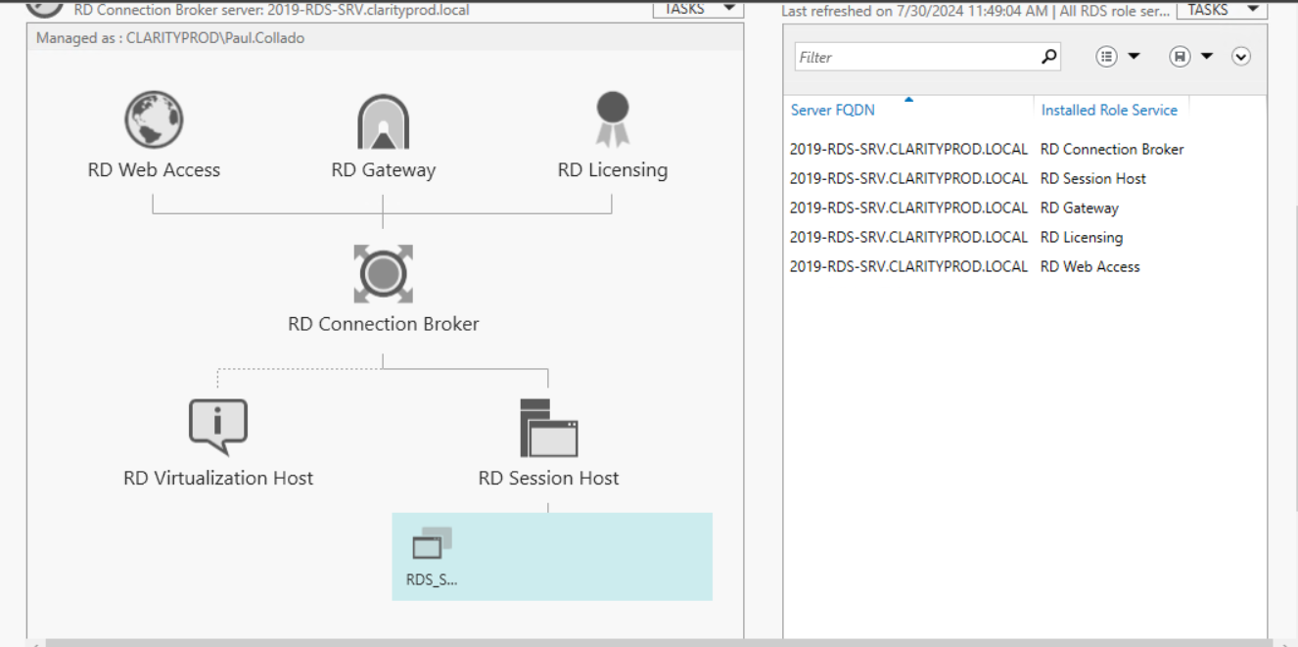
CAL Licenses to allow up to 10+ concurrent RDP sessions to configured servers were purchased. The licensing information was store in Vaultwarden under RDS repository including server information.
In order to configure additional servers to increase their concurrent RDP sessions, please login to the client server in question
From Server Manager, please select Manage> Add Roles and Features Wizard
Select the Remote Desktop Services option
When presented for the additional sub-options, please select only:
- Remote Desktop Session Host
- Remote Desktop Connection Broker
Perform the installation and restart server to complete the installation.
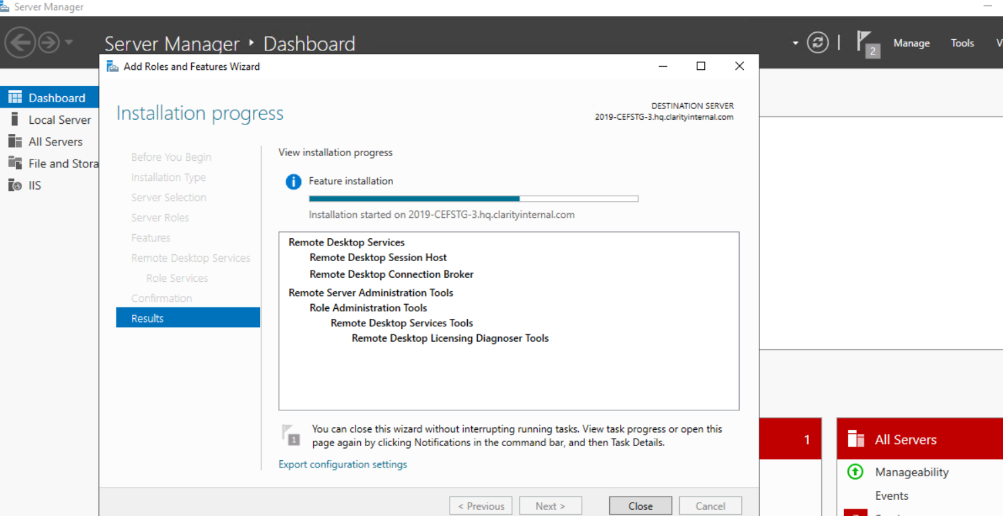

After server restart and successfully completion of the RDS services, please go to:
Server manager> from the top right “Tools”
From the drop down menu, please select “Remote Desktop Services” and Select “Remote Desktop Licensing Diagnoser”
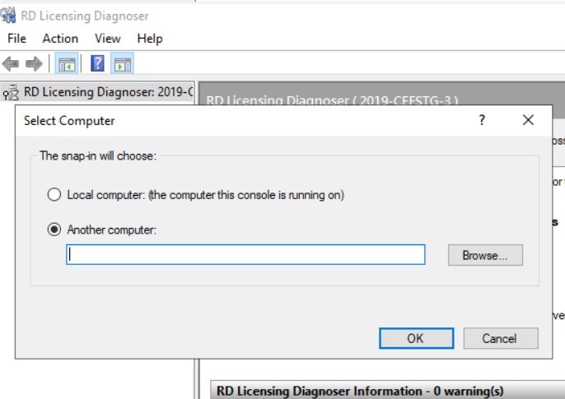
From the RD Licensing diagnose screen, please select Action> Connect to Server
From the Select Computer screen, please select the “Another Computer” radio button
On the blank field, please enter the IP address for the server to connect for available RDP licenses depending on the domain the current host resides at:
ClarityPROD domain: [10.200.200.20]
HQ Domain: [10.100.1.3]
After successfully connecting to the required Licensing Broker server, you should see the below screen with no errors and your server will be ready to accept multiple simultaneous RDP connections:
