Clarity Process & Policies Cheat Sheet
Project management
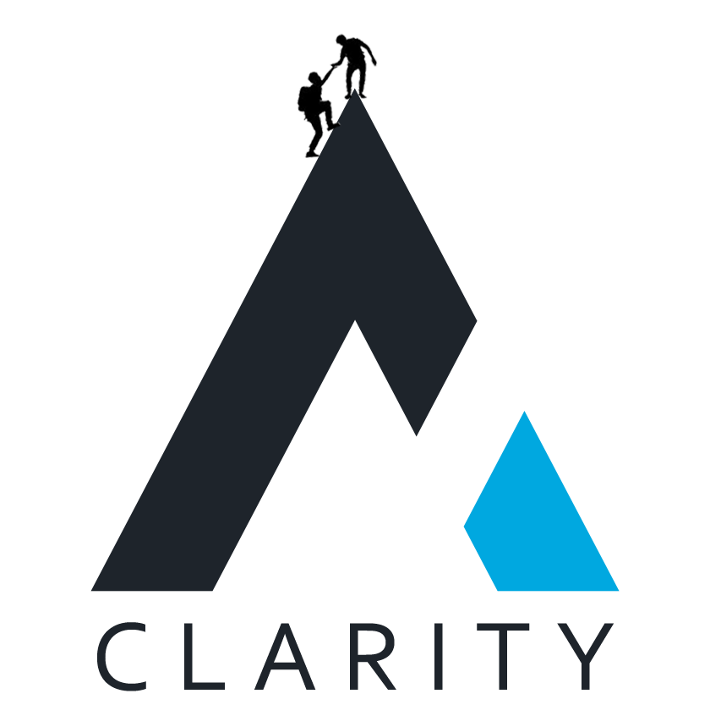
Contents
Overview & Purpose 3
General Clarity Articles 3
PTO Policies 3
Logging Time 3
Role Specific Articles 3
Invoicing 3
Recurring Tasks & SOPs 3
Best Practices & General Information 4

Overview & Purpose
The purpose of this document is to provide team members with the links to common Nuclino articles that they might require while working at Clarity as well as for their role.

General Clarity Articles

PTO Policies
- PTO Basics: https://app.nuclino.com/ClarityTeam/Clarity/PTOVacation-and-General-Sick-Days-etc-fde4ee8b-f5a2-4e3b-ae9f-d1e7ef48e0f0
- Out of Office Process: https://app.nuclino.com/ClarityTeam/Clarity/Out-of-the-Office-Process-d6c242bb-0abf-4fc0-89ed-b484f388c418
- Rippling How To’s: https://app.nuclino.com/ClarityTeam/Clarity/Rippling---Time-Off-3c52ea0d-6cfd-4b10-86a8-0dbff1d283b0
- Annual Company Holidays: https://app.nuclino.com/ClarityTeam/Clarity/Annual-Company-Holidays-b0547556-2820-42cf-b0a4-132b6299d288

Logging Time
- Easy Projects: http://ep.clarityinternal.com/app/TimeLogs.aspx
  - Credentials will typically be provided by the Operations Team
- Time Logging Policy: https://app.nuclino.com/ClarityTeam/Clarity/Time-Entry-Policy-and-Consequences-e2136d51-994d-4868-a0c4-68499c6a65ac
- Client Billable Hours: https://app.nuclino.com/ClarityTeam/Clarity/Client-Billable-Hours-82020b7f-b1e1-4344-8104-6bee1ed8dae2

Role Specific Articles
- Overview of Tasks & Breakdown: https://app.nuclino.com/ClarityTeam/Clarity/Project-Management-Tasks-Breakdown-765dda75-4a77-490c-a147-dec8b5585188
- Glossary of Terms: https://app.nuclino.com/ClarityTeam/Clarity/PM-Glossary-of-Terms-1fdcf559-8a49-4811-be1c-213f298e5d10

Invoicing
- PM Invoice Spreadsheet Info: https://app.nuclino.com/ClarityTeam/Clarity/PM-Invoice-Spreadsheet-Info-9413b131-d12c-43ab-8252-491828ef8068
- Invoice Meetings: https://app.nuclino.com/ClarityTeam/Clarity/Invoice-Meetings-c5a33b47-acea-4f97-a82f-0f7705c4eef7
- PSR Generation: https://app.nuclino.com/ClarityTeam/Clarity/PSR-Generation-d999681f-f8e7-4dea-af28-b6815b5ba57c
- Change Requests: https://app.nuclino.com/ClarityTeam/Clarity/Change-Request-Training-683c8108-35d9-44b5-86b8-14bd4339bdad
- Sprint Based Billing: https://app.nuclino.com/ClarityTeam/Clarity/Sprint-Based-Billing--Expectations-and-workflow-9aafc1dd-e22d-43a7-a7dd-0ef3e9eef750

Recurring Tasks & SOPs
- PM Shred Sessions: https://app.nuclino.com/ClarityTeam/Clarity/PM-Shred-Sessions-805a364a-e8c0-4a00-828b-327465ac504a
- Project Financial Health Check In: https://app.nuclino.com/ClarityTeam/Clarity/Project-Financial-Health-Check-In-d399d0f0-8246-4bd0-a4ab-53b77828718f
- Azure / EP Audit: https://app.nuclino.com/ClarityTeam/Clarity/EP-Resource-Allocation-1608e5e1-bae3-4d73-85c9-31a46078bc13
- Timeline Overview: https://app.nuclino.com/ClarityTeam/Clarity/Timeline-Overview-e9decd98-bd0d-4ff4-a0fd-bcddc037dc78
- Teams Project Update: https://app.nuclino.com/ClarityTeam/Clarity/Teams-Project-Update-a2f2bba8-e150-4f21-a945-bfa9e6b68196
- Code Complete Audit: https://app.nuclino.com/ClarityTeam/Clarity/Code-Complete-Audit-40bd3167-93f5-4842-8c99-a781837276a3
- Backlog Refinement Meeting: https://app.nuclino.com/ClarityTeam/Clarity/Backlog-Refinement-Meeting-fc7d811b-4d10-4d8a-a1c5-23c96e47ee1f
- Backlog Cleanup: https://app.nuclino.com/ClarityTeam/Clarity/Backlog-Cleanup-Feature-Parity-Check-e0599625-72d7-4b88-82b9-1ba8b57db857
- UAT & Test Cases: https://app.nuclino.com/ClarityTeam/Clarity/UAT-Test-Cases-71a810b8-5e74-4026-a518-440f1017173b

Best Practices & General Information
- SDLC: https://app.nuclino.com/ClarityTeam/Clarity/SDLC-86bf6cb8-bbbb-4357-9847-2db9d6125866
- Needs Reallocation: https://app.nuclino.com/ClarityTeam/Clarity/CVI-Needs-Reallocation-Best-Practices-1c7b783b-1ee6-467f-a132-6720310e12c2
- Sprint Planning: https://app.nuclino.com/ClarityTeam/Clarity/Sprint-Planning-Best-Practices-d1c8b074-22bd-43e0-a508-3a1014fb4031
- Calendar: https://app.nuclino.com/ClarityTeam/Clarity/Calendar-Best-Practices-e9f48a40-d4d4-4934-8a81-fff4f7e1e1c8

